

Lubrication of Landon Kingsway Free Fall Fire Valve

Step 1: Remove the lubricating screw from the end of the square shaft. ***(Important Ensure valve is in the open condition)***

Step 2: Fill the reservoir inside the shaft with lubricant stick

Step 3: Replace the screw and tighten the screw until a definite increase in resistance is felt, inserting further lubricant as necessary.

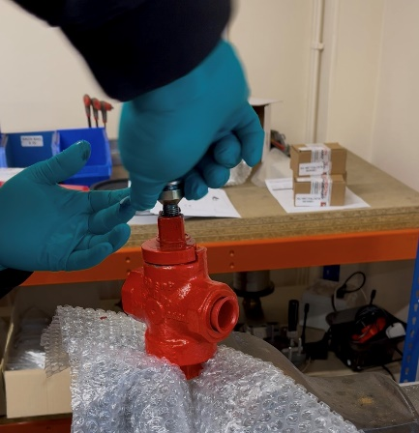

Step 4: ‘Pump’ the valve lever up and down several times to ensure the valve is free-moving.

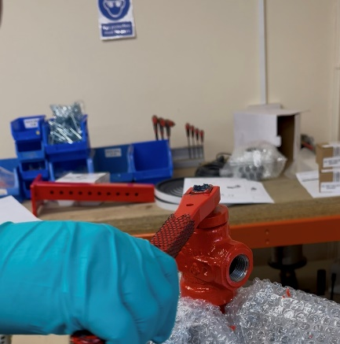

* Remove excess build-up of lubrication from valve when in the open position between the plug and valve body with rag.
* Use only a part or just one stick of lubrication at one time and test for leak tightness of system to atmosphere and pass seat (valve in close position)
* Always wear gloves